EMPLOYEE DATABASE

SQL QUERY

create database Employee_Database_CS152;

use Employee_Database_CS152;

create table dept(no varchar(20) primary key, dname varchar(20), dloc varchar(20));

create table employee(empno int,ename varchar(20),mgr_no int,hiredate varchar(20), sal float,

no varchar(20),primary key(empno,no), foreign key(no) references dept(no));

create table incentives(empno int, date VARCHAR(20), amt float,primary key(empno,date),foreign

key(empno) references employee(empno));

create table project(pno int primary key, ploc VARCHAR(20),pname varchar(20));

create table Assingnedto(empno int, pno int,job_role text, primary key(empno,pno), foreign key(empno)

references employee(empno), foreign key(pno) references project(pno));

insert into dept values(1,"cse","pj");

insert into dept values(2,"ise","pj");

insert into dept values(3,"csds","pg");

insert into dept values(4,"ece","pg");

insert into dept values(5,"aiml","pj");

insert into employee values(101,"mdr",100,"12/01/1999",100000,1);

insert into employee values(201,"sak",200,"17/01/2020",50000,2);

insert into employee values(301,"grp",100,"01/09/2004",30000,3);

insert into employee values(401,"sws",101,"03/08/2000",10000,4);

insert into employee values(501,"sks",101,"29/2/2008",90000,5);

insert into incentives values(101,"12/03/2004",50000);

insert into incentives values(201,"17/03/2024",25000);

insert into incentives values(301,"01/12/2019",15000);

insert into incentives values(401,"03/11/2019",5000);

insert into incentives values(501,"29/4/2019",45000);

insert into project values(10,"bng","chatbot");

insert into project values(40,"delhi","ml model");

insert into project values(50,"bombay","blockchain");

insert into project values(30,"chennai","stocks");

insert into project values(80,"mysore","android app");

insert into Assingnedto values(101,10,"devops");

insert into Assingnedto values(201,40,"sde");

insert into Assingnedto values(301,50,"manager");

insert into Assingnedto values(401,30,"jpa");

insert into Assingnedto values(501,80,"pa");

select * from dept;

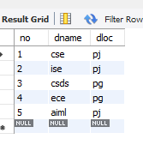

select * from employee;

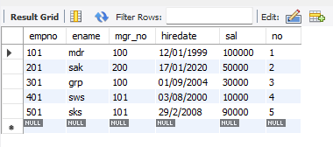

select * from incentives;

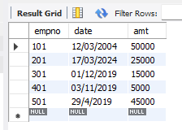

SELECT * from project;

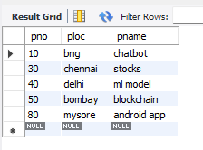

select * from Assingnedto;

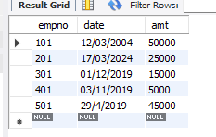

Retrieve the employee numbers of all employees who work on

project located in Bengaluru, Hyderabad, or Mysuru

SELECT DISTINCT employee.empno

FROM employee

JOIN Assingnedto ON employee.empno = Assingnedto.empno

JOIN project ON Assingnedto.pno = project.pno

WHERE project.ploc IN ('bng', 'mysore', 'hyderabad');

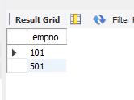

Get Employee ID’s of those employees who didn’t receive incentives

SELECT e.ename AS Employee_Name,

e.empno AS Employee_Number,

d.dname AS Department,

a.job_role AS Job_Role,

d.dloc AS Department_Location,

p.ploc AS Project_Location

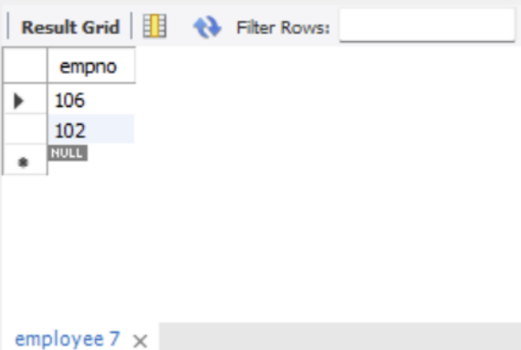

Write a SQL query to find the employees name, number, dept,

job_role, department location and project location who are working for

a project location same as his/her department location.

